Chargerettes Track Excels at Jordan Relays

Featured Image:
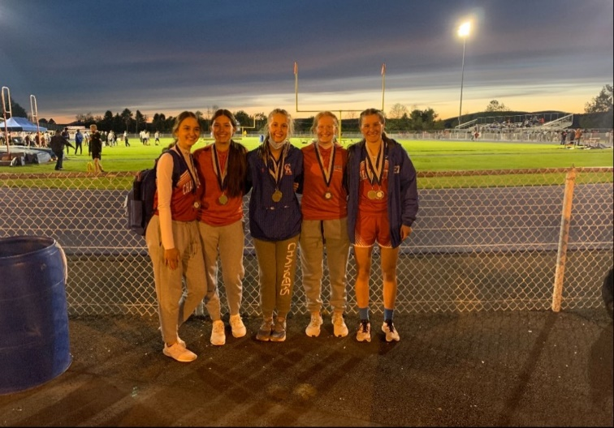
The Chargerettes Track team took home plenty of medals at the 65th Annual Jordan Relays. From left to right: Alyssa Cosklo, Megan Cosklo, Maddie Borders, Giana Arnese, and Rachel Korty.

In the first meet of the track & field postseason- the 65th Annual Jordan Relays, our Chargerettes Track team excelled. They finished in a tie for sixth place in Class AA with just five girls competing in four events. The Girls won the 1600 Sprint Medley with a total time of 4:40.96, where the first two athletes run a 200, the third athlete runs a 400, and the last athlete runs an 800. Megan and Alyssa Cosklo both ran a 200, Maddie Borders ran the 400, and Rachel Korty ran the 800. The 1200 Sprint Medley (400-200-200-400) placed third, with Rachel Korty and Maddie Borders running the 400’s and Megan Cosklo and Giana Arnese running the 200s.
“We were the underdogs coming into the meet, but I am so proud of us working hard to come out on top,” explained senior captain Giana Arnese. The Girls look ahead to the District Championship Meet, which will be held next Monday at North Pocono. The Carbondale Area School District congratulates the Girls on their Jordan Relay accomplishment and wishes them the best of luck at Districts!

